**E-Library Management System**



**Submitted By: Uttakarshini Mishra**

**Shilpi Sharma**

**Submitted To: Mr. Vikas Kumar**

**Table of Contents**

1. **Introduction**
2. **Objectives**
3. **System Overview**
4. **Features and Functionalities**
5. **Technology Stack**
6. **Implementation Details**
7. **Challenges Faced**
8. **Testing and Results**
9. **Future Scope**
10. **Conclusion**
11. **References**

**Introduction**

* **Overview: Brief explanation of the need for an e-library system in today’s digital age.**
* **Scope: Define the scope of your system (e.g., managing book inventories, search functionality, dataset integration).**
* **Purpose: Explain the project's aim to streamline library management and enhance user experience.**

**Objectives**

* **Develop a user-friendly interface for library browsing.**
* **Implement search functionality based on various criteria (title, author, genre, etc.).**
* **Integrate external datasets (e.g., PDF/CSV) into the system.**
* **Reduce manual errors and enhance resource accessibility.**

**System Overview**

* **Modules:**
  + **Admin Module: For managing book inventories, tracking borrowed books, and generating reports.**
  + **User Module: For searching books, viewing details, and borrowing resources.**
* **Architecture:**
  + **Describe the architecture (e.g., client-server model).**
* **Data Flow:**
  + **Provide a diagram or explanation of data flow between frontend, backend, and database.**

**Features and Functionalities**

* **Search Functionality: Search books by title, author, genre, etc.**
* **Dataset Parsing: Integration of PDF/CSV datasets for updating book records.**
* **Table Display: Dynamic table population and filtering.**
* **User Authentication (if applicable): Admin and user roles.**
* **Statistics: Overview of book availability, borrow rates, and popular genres.**

**Technology Stack**

* **Frontend: HTML, CSS, JavaScript, React.js**
* **Backend: Node.js, Express.js**
* **Database: MongoDB**
* **Libraries/Tools:**
  + **pdf-parse for PDF parsing.**
  + **PapaParse for CSV integration.**

**Screenshot/ photos**

**Code:**

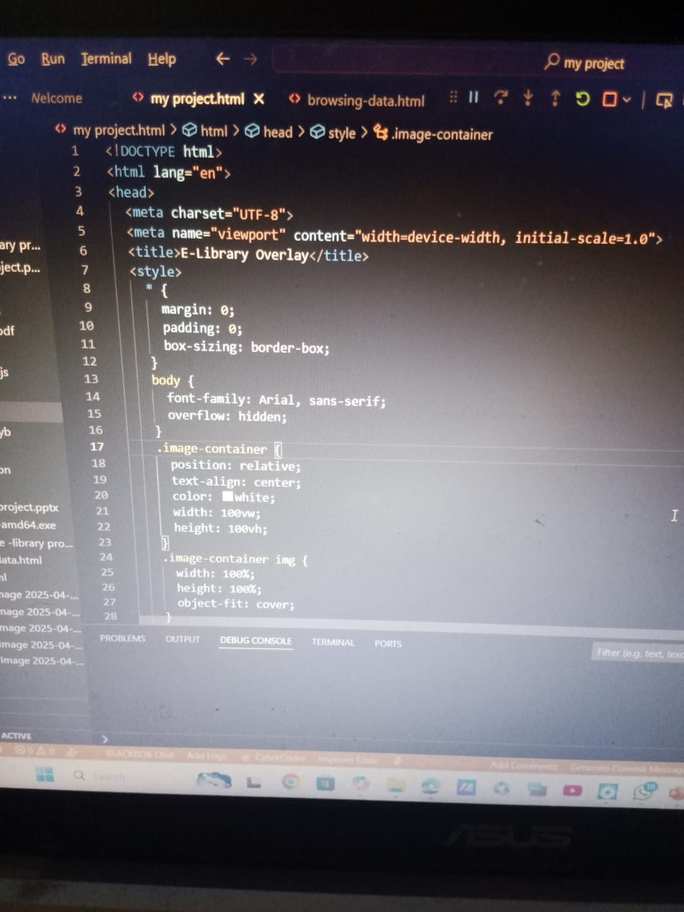

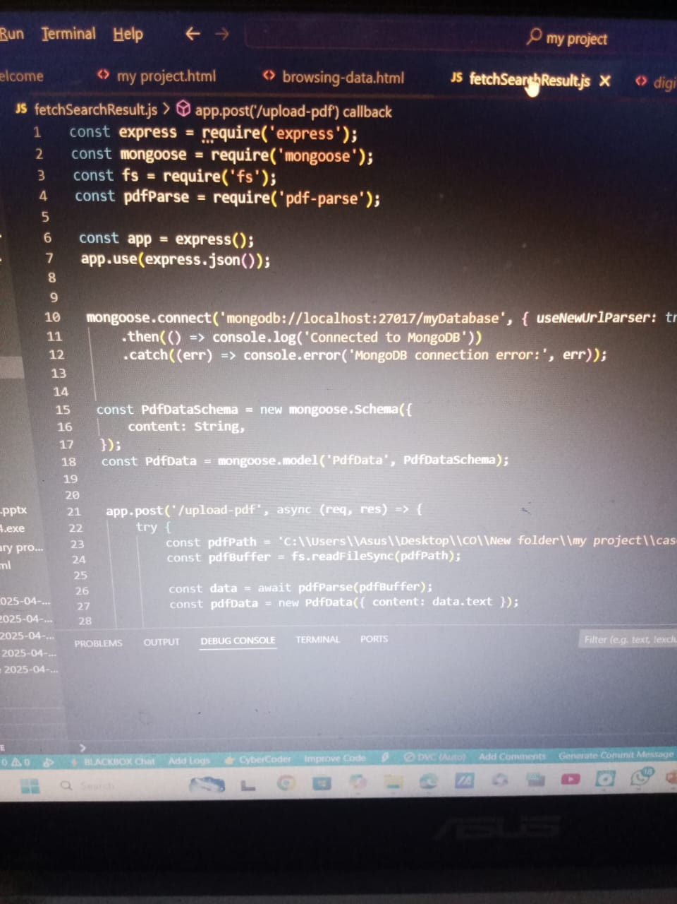

**Photos of implementation of code:**



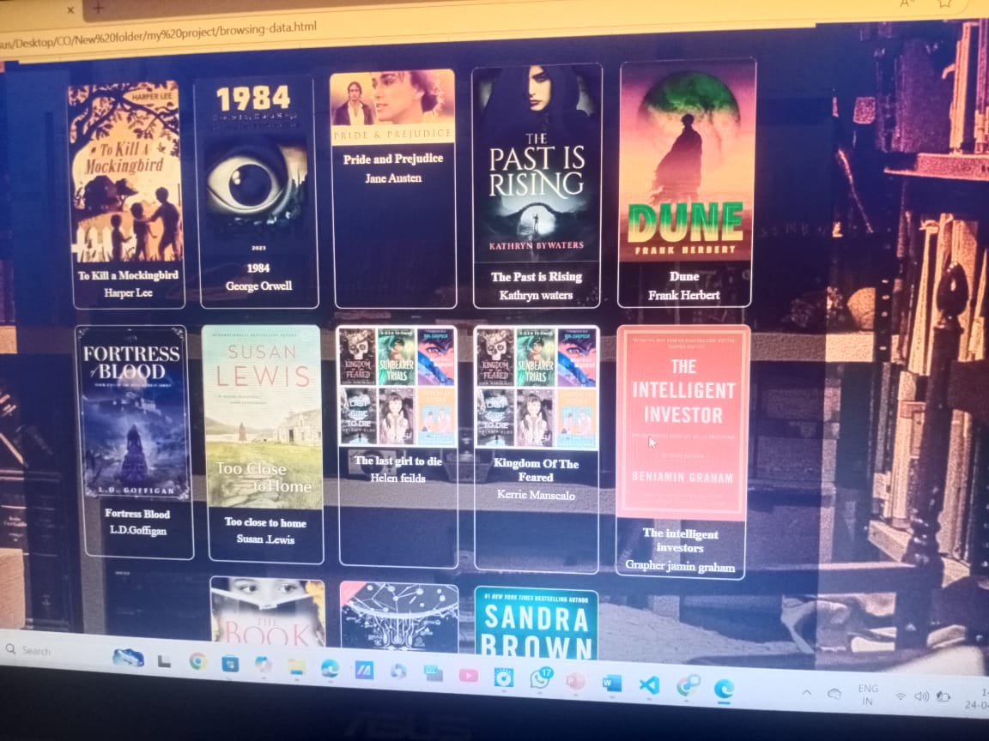

**Implementation Details**

* **Frontend Development:**
  + **How the UI was designed to ensure user-friendly navigation.**
  + **Integration of dynamic tables for displaying books.**
* **Backend Development:**
  + **API endpoints for handling CRUD operations.**
  + **Integration of the parsed dataset into the database.**
* **Dataset Handling:**
  + **Process of extracting data from PDF/CSV files.**
  + **Examples of parsed book entries.**

**Challenges Faced**

* **Parsing PDF/CSV datasets with inconsistent formats.**
* **Ensuring seamless integration between frontend and backend.**
* **Managing performance for large datasets in search functionality.**
* **Synchronizing updates between the database and frontend.**

**Testing and Results**

* **Testing Scenarios:**
  + **Test cases for search functionality, dataset upload, and API responses.**
  + **Example inputs and outputs for key functionalities.**
* **Results:**
  + **Accuracy of search results.**
  + **Performance metrics (e.g., response time).**

**Future Scope**

* **Adding AI-based recommendations for users.**
* **Expanding the system to support multimedia libraries.**
* **Implementing real-time notifications for overdue books or new arrivals.**
* **Enhancing accessibility through multilingual support.**

**Conclusion**

The E-Library Management System represents a significant leap forward in modernizing traditional library operations. By integrating powerful search capabilities, dynamic data handling, and intuitive user interfaces, it offers a seamless experience for both library staff and users. The project's focus on dataset integration, coupled with the use of advanced technologies like Node.js and MongoDB, ensures scalability and efficiency. Additionally, the system reduces manual effort, enhances accuracy, and fosters sustainability by minimizing paper-based processes. This initiative not only streamlines library management but also sets the groundwork for further innovations such as AI-driven recommendations and multimedia integration, paving the way for a truly comprehensive digital library experience.

**References**

* **Libraries and Frameworks:**
  + **Express.js: Framework for backend development**
  + **MongoDB: NoSQL database for storing book and user data**
  + **pdf-parse: Library used for extracting data from PDFs**
  + **PapaParse: Tool for handling and parsing CSV files**
* **Online Resources:**
  + **Official documentation for Node.js, Express.js, and MongoDB**
  + **Tutorials and guides from platforms like** [**MDN Web Docs**](https://developer.mozilla.org/) **and** [**Stack Overflow**](https://stackoverflow.com/)
* **Books and Articles:**
  + **Research papers and articles on digital library management systems**
* **Development Tools:**
  + **Visual Studio Code for code editing**
  + **Postman for API testing**